This question and 267 in sheet are the same.

See this board is m\*n. Here we need to divide the board into m\*n pieces. We need the minimum cost of dividing the board.

Also, above is given the cost of cutting the board above 4 1 2 for horizontal cut and 2 1 3 1 4 for vertical cut.



Also, this will be the cost formulae.

Now to ding the pieces in above formulae .see the below picture

Here cost of cutting is 1 and the pieces it is going through is 3 hence cost here will be 1\*3.

Same logic here that cost of cutting is 2 and pieces cutting through is 3.

See logic here should be that when we cut for the first time there is only 1 piece it will cut through. Hence, we will sort the cost of cut in descending order and find the min cost.

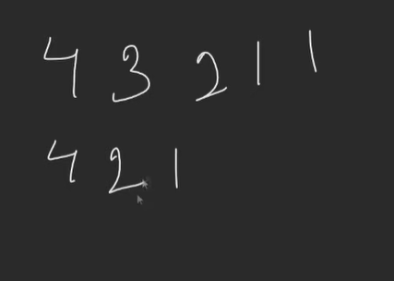

See sorted both the horizontal and vertical cost .see here min cost would come when multiply greater cost with min number of pieces and this would give min cost.

See this will give the horizontal and vertical count of pieces.

See in both we will check for greatest number hence can pick any 4.take vertical 4.

See here when we take vertical cut here vertically 2 pieces after cut would come. Hence when take horizontal for cut there will be 2 pieces and same is true for when horizontal taken there will be 2 pieces when cut for vertical cut.

Code:



